CALL FOR PAPERS

MobiCom 2012

The Eighteenth Annual International Conference
on Mobile Computing and Networking

August 22-26, 2012 ● Istanbul, Turkey

http://www.sigmobile.org/mobicom/2012/

Sponsored by ACM SIGMOBILE
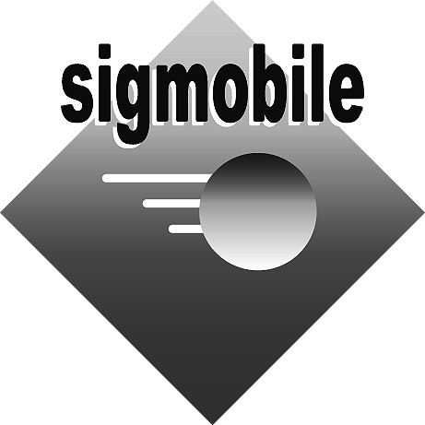


General Chair

Özgür B. Akan
Koc University, Turkey

Eylem Ekici
The Ohio State University

Program Co-Chairs

Lili Qiu
Univ. of Texas at Austin

Alex C. Snoeren
UC San Diego

Steering Committee

Victor Bahl
David B. Johnson
ACM Program Coordinator

Fran Spinola

FOR MORE INFORMATION:
Please contact the General Chair or Program Co-Chairs for more information. For information on ACM SIGMOBILE and the MobiCom series of conferences, see http://www.sigmobile.org or contact mobicom_info@acm.org

ACM MobiCom 2012, the Annual International Conference on Mobile Computing and Networking, is the eighteenth in a series of annual conferences sponsored by ACM SIGMOBILE dedicated to addressing the challenges in the areas of mobile computing and wireless and mobile networking. The conference will be held in Istanbul, Turkey, in late August, or early September 2012.
The MobiCom conference series serves as a highly selective, premier international forum addressing networks, systems, algorithms, and applications that support mobile computers and wireless networks. In addition to the regular conference program, MobiCom 2012 will also include a set of workshops, panels, research demonstrations, and a poster session that includes the ACM Student Research Competition. More information on these activities, including submission deadlines, can be found at http://www.sigmobile.org/mobicom/2012.
PAPERS: Authors are invited to submit full papers presenting new research related to the theory and practice of mobile computing and wireless networking that pertain to layer two or above of the OSI protocol stack. Areas of interest include, but are not limited to, the following.
- Architectures, protocols, and algorithms for various wireless and mobile networks, such as wireless LANs, wireless mesh networks, cellular data networks, delay-tolerant networks, mobile ad hoc networks, sensor networks, personal area networks, and vehicular networks  - System design, implementation, and evaluation of wireless systems and mobile applications  - Real-world measurements and characterization  - Performance-oriented design and evaluation focused on networks and mobile applications  - Testbed design and implementation  - Cross-layer design for mobile and wireless networks ranging from the PHY layer to applications  - Modeling, simulation, emulation and measurement of mobile systems | - Networks involving novel technologies such as UWB, MIMO, directional antennas, software radios, visible light communications and underwater networking  - Architectures, algorithms and protocols for dynamic spectrum usage, white spaces, and cognitive networks  - Techniques that deal with low power and energy limitations  - Operating system and middleware support for mobile computing and networking  - Security, privacy, and trustworthiness of mobile and wireless systems  - Emerging topics, e.g., robotic swarms, 60 GHz networking, social networking and novel applications enabled by mobile and wireless networking systems  - Integration and interworking of wired and wireless networks  - Foundational underpinnings of wireless networks
MobiCom 2012 will be a diverse conference, and we strongly encourage the submission of mobile systems, experimental and theoretical papers. The program committee will evaluate each paper using metrics that are appropriate for the topic area. For example, a systems or experimental paper in the protocol area will be evaluated based on the innovations in the protocol design, practical implementation, and realistic evaluation, whereas a more theoretical paper may be evaluated mostly based on innovation within the design of the algorithm and its provable properties. At the same time, the evaluation of wireless and mobile networking technologies is challenging because of the significant impact that the physical environment has on performance. For this reason, all papers must carefully describe and justify the evaluation methodology that is used and identify its strengths and weaknesses.
The program committee will referee all papers, and accepted papers will be published in the conference proceedings.
CHALLENGES PAPERS: The conference also strongly encourages the submission of short papers in the field of mobile computing and wireless networking that present revolutionary new ideas or that challenge existing assumptions prevalent among the research community. These Challenges Papers should provide stimulating ideas or visions that may open up exciting avenues and influence the direction of future research. Descriptions of new products or evolution of existing work are not appropriate topics for papers in this category. While an exhaustive evaluation of the proposed ideas is not necessary, insight and in-depth understanding of the issues is expected. Challenges Papers will be reviewed by the MobiCom program committee and will be part of the technical program and published in ACM MobiCom proceedings. They should be submitted using the same submission procedure adopted for the full papers. The title of these papers must start with the word "Challenge:" i.e., "Challenge: Rest of the Title."
SUBMISSION INSTRUCTIONS: All paper submissions will be handled electronically. Authors should prepare a PDF version of their full paper. Papers must (i) be no longer than 12 pages (8 pages for "Challenges" papers), (ii) be in font size no smaller than 10 points, (iii) have pages in double column format with each column having dimensions 9.25” X 3.33”, a space of 0.33” between the two columns, and with no more than 55 lines of text per column, and (iv) fit properly on US letter-sized paper (8.5” X 11”). More detailed instructions will be available in the conference web pages.
All submitted papers will be judged based on their quality through double-blind reviewing, where the identities of the authors are withheld from the reviewers. See the MobiCom 2012 website for detailed instructions to authors on preparing a double-blind manuscript. Authors' names must not appear anywhere in the paper or in the PDF file. Submitted papers must be original work, and a paper with substantial similarity must neither be already published, nor be currently under review for publication in any other venue. Please direct any questions about the paper submission process to the Program Co-Chairs at mobicom_pcchairs@acm.org.
BEST PAPER AWARD: All papers will be considered for the Best Paper Award. The program committee will select a number of candidates for the award among accepted papers. The winner will be selected at the conference, considering both the paper and the presentation. The winner will receive a plaque and a cash award.

IMPORTANT DATES:
Abstract submission due:
March 2, 2012 (8:00PM EST)
Paper submission due:
March 9, 2012 (8:00PM EST)
Notification of acceptance:
June 6, 2012
Camera-ready version due:
July 2, 2012

